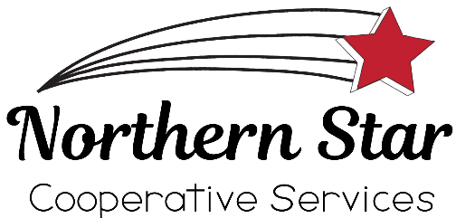

Are you looking to join a successful and growing energy company? Are you looking for a career with good advancement potential? Do you have the desire to learn as you work? If so, Northern Star Cooperative Services may be the place for you. We are a customer focused energy cooperative looking to fill a Fuel Oil/Propane Delivery position based out of our Long Prairie facility.

*We offer a competitive wage and benefits package
*We offer a flexible work schedule
*We offer training and mentoring
*We operate under a customer focused philosophy
*We are accepting applications for full time and part time positions

A Great Attitude, Commercial Driver’s License, HAZMAT, Tanker and Air Brake Endorsements and a safe driving record will be required for this position.

Delivery Experience is preferred, but not required. For more information on this position or to get an application, please contact our Long Prairie office at 320-732-3422.

