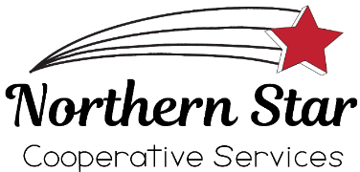 Northern Star Cooperative Services

Job Title: Shift Lead Position - Evenings/Weekends
Job Location: Deer River Convenience Store
Number of Positions Open: 2
Hours: Up to 40 Hours/Week
Job Requirements: Successful applicants must be able to work a fixed schedule including 2PM-10PM shifts Monday through Sunday and 4:30AM-12:30PM Saturday and Sunday on a rotating weekly basis. A great attitude, leadership ability, a customer-based focus, and the ability to work in a multi-generational, team environment are essential. Basic computer skills are required, as well as very good written and verbal communication skills. Management and/or merchandising experience is preferred but not required. A knowledge of cooperative business principles is also preferred. The successful applicants must agree to achieving Food Service Safety Certification within 60 days of hire date if they do not already hold this certification.

Job Description includes but is not limited to: This position will assist the Store Manager in the overall operation of the Deer River C-Store location, ensuring customer satisfaction, sales goals, and operational efficiency are met.
Application Deadline: OPEN UNTIL FILLED
Wage/Benefits: The successful applicants will receive wages starting at $16 per hour and qualify for Northern Star Cooperative’s full-time employee benefit package, including paid time off, holiday pay, 401K, and health insurance.
How to apply: Interested parties can apply online at https://northernstarcoop.com/job-openings/?et_fb=1&PageSpeed=off , or picked up an application at our Main Office or at any of our convenience store locations. Applications should be addressed to Convenience Store Manager Margie Schumacher at PO Box 458, Deer River, MN or delivered to the Deer River Convenience Store or Main Office in a sealed envelope.

